Write a menu driven program with 4 options (Insert, Delete, Display, and Exit) to demonstrate the working of Queues using arrays

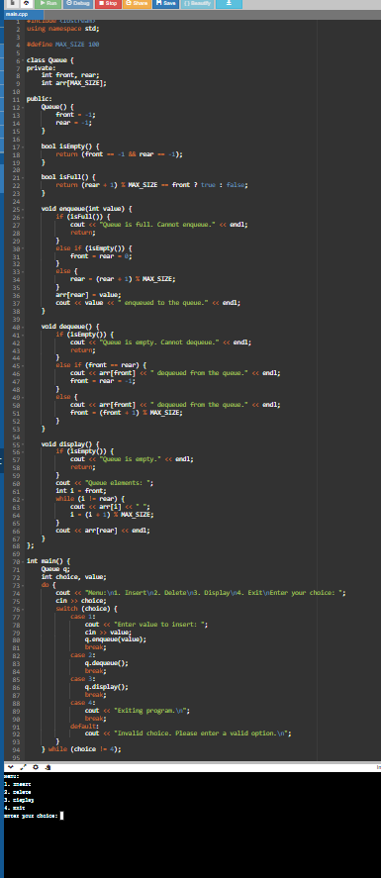

Write a menu driven program with 4 options (Insert, Delete, Display, and Exit) to demonstrate the working of Queues using linked-list.

.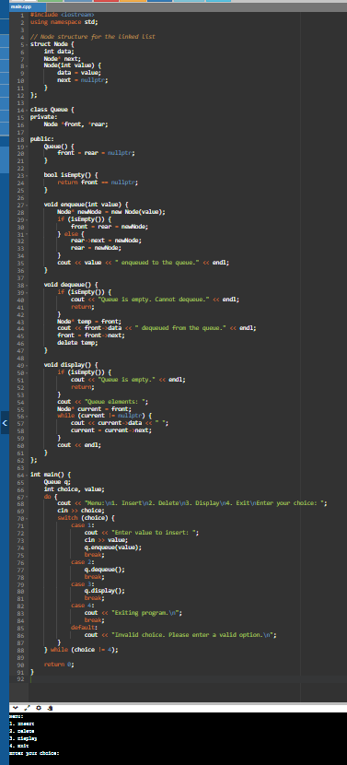

. Write a menu driven program with 4 options (Insert, Delete, Display, and Exit) to demonstrate the working of Circular Queues (arrays.) 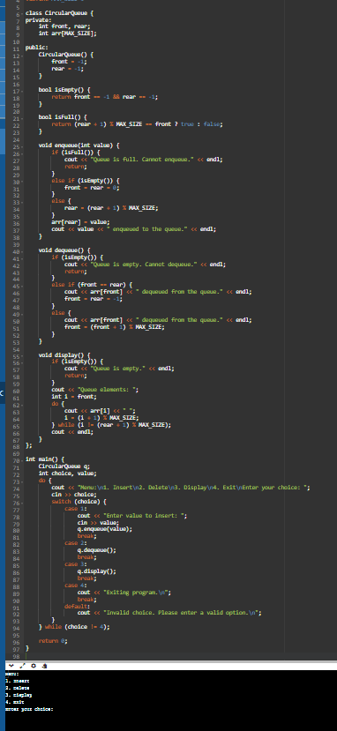zz